Lab 1. Install Flutter and Dart SDK ( Write a simple Dart program , Flutter widgets)

Lab 1.1 . Install Flutter and Dart SDK
Step 1. Install Flutter
- Download prerequisite software
  - Install Git for Windows
  - Download and install Visual Studio Code
- Install and set up Flutter
  - Add the Flutter extension to VS Code
  - Install Flutter with VS Code
  - Open the command palette in VS Code.
Go to View > Command Palette or press Control + Shift + P.
Select Flutter: New Project
- Validate your setup
$ flutter doctor -v
Step 2. Set up Android development
- Choose your development platform
  - Windows, MacOS, Linux, ChromeOS
- Set up Android tooling
  - Install Android Studio
  - Install Android SDK and tools
- Agree to the Android licenses
$ flutter doctor --android-licenses
- Set up an Android device
  - Android emulator
    - Create Virtual Device
    - Select either x86 Images or ARM Images depending on if your development computer is an x64 or Arm64 device
    - Validate your setup
$ flutter doctor
    - Check for Android devices
$ flutter emulators hoặc $ flutter devices
Step 3. Create a new Flutter app
- Open the command palette in VS Code (Cltr + Shift + p)
  - Select the Flutter: New Project command.
- Choose the Application template
- Create or select the parent directory for your new app's folder.
- Enter a name for your app
  - masv_hoten_lab1_1
- Open the lib directory, then the main.dart file
Step 4. Run your app on android emulator
- Open the command palette in VS Code (Cltr + Shift + p)
- Select the Flutter: Launch Emulator command
- Select the Flutter: Select Device command
  - From the Select Device prompt, select Android emulator
  - Run or start debugging your app
    - Go to Run > Start Debugging or press F5
    - $ flutter run
Task 1: Run the program and record the results.

Lab 1.2. Write a simple Dart program
Step 1. Create a new Dart project
$ dart create masv_hoten_lab1_2
Step 2. Open the bin/ masv_hoten_lab1_2.dart file in your Dart project and peplace the existing code
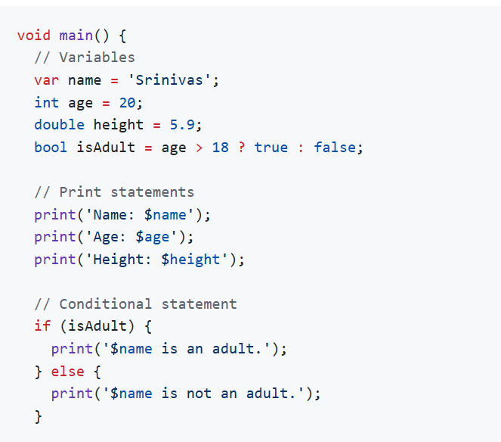
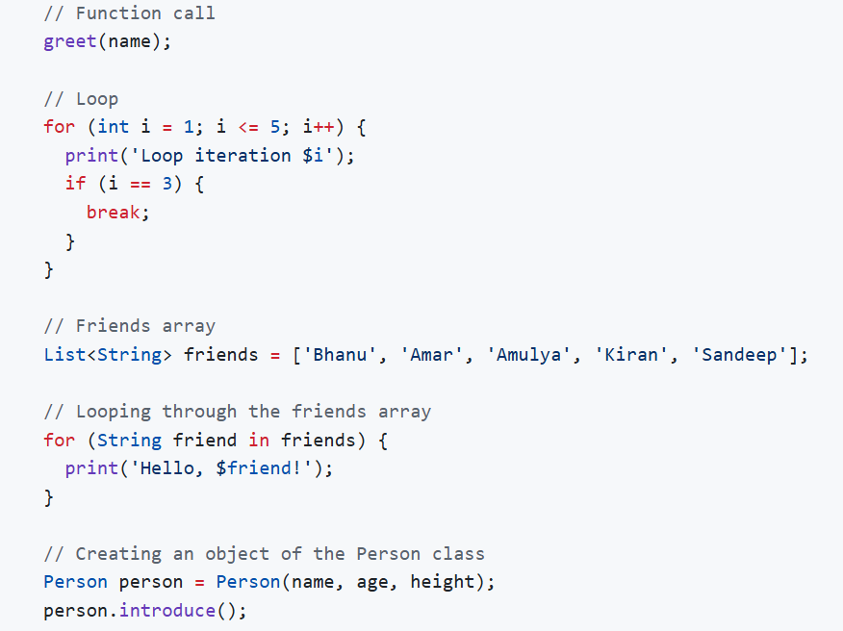
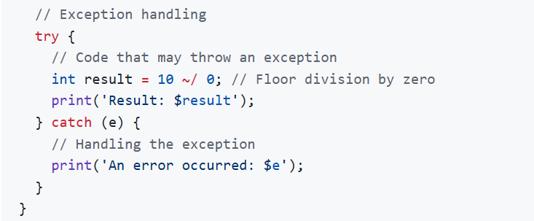
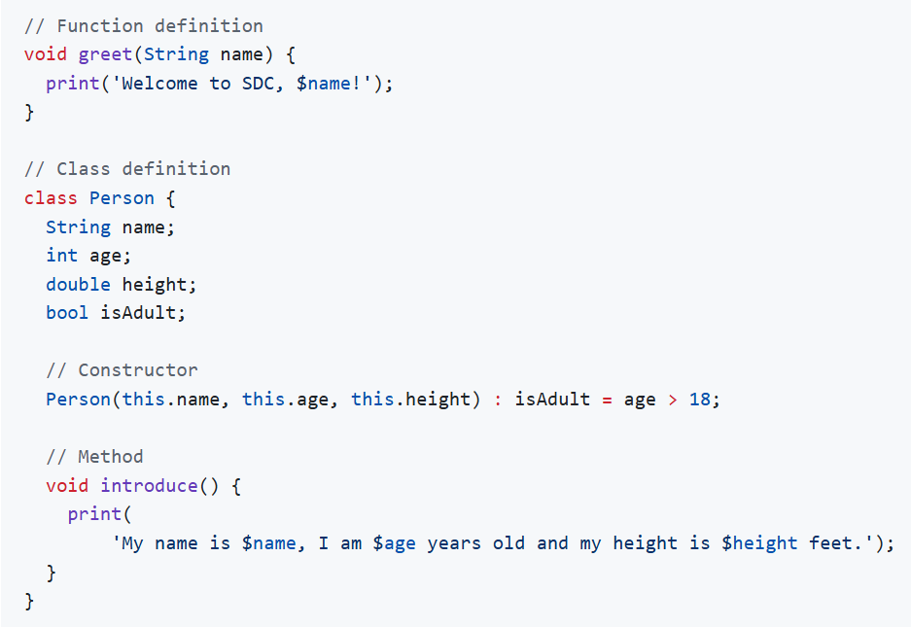
Step 3. Run app
$ dart run
Task 1: Run the program and record the results.
Task 2: Explain the code and point out the differences compared to the programming language you have learned.

Lab 1.3. Explore various Flutter widgets
Objective
In this lab experiment, we will explore various Flutter widgets such as Text, Image, and Container. Follow the steps below to set up a basic Flutter application and customize it according to your needs.
Step 1. Create a new Flutter project by running the following command in your terminal:
$ flutter create masv_hoten_lab1_3
Step 2. Get the image flutter_logo.png from wikipedia and save it in the assets/images/ directory of your Flutter project or replace the image path 'assets/images/flutter_logo.png' with the actual path to your image file and then save the file.
Step 3. Open the pubspec.yaml file in your Flutter project and add the following lines after flutter: to include the image asset in your project:
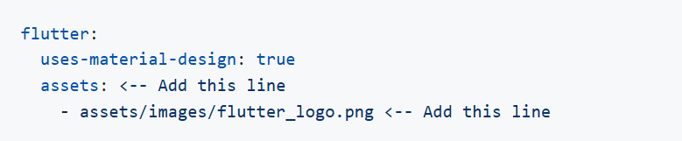
Save the file.
Step 4. Open the lib/main.dart file in your Flutter project and peplace the existing code
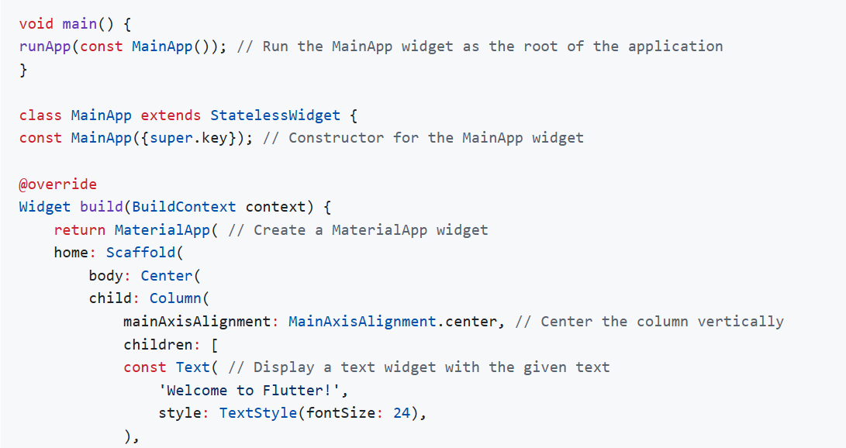
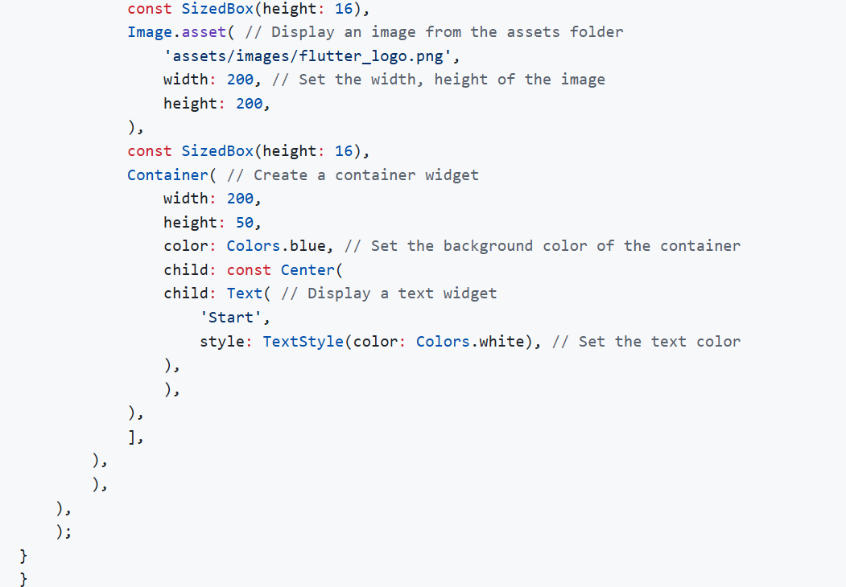
Step 5. Run your Flutter project using the following command:
$ flutter run
Step 6.
- Enter r to hot reload the app and see the changes you made to the code.
- Enter q to quit the app.
Task 1: Run the program and record the results.
Task 2: Explain the code.

